**Aim**: Perform basic CLI commands to configure switch and router.

**Step – 1 :-** Open Cisco Packet tracer and take one PC and Router.

**Step – 2 :-**  Connect a Console Cable between the console port of router and the RS232 port.

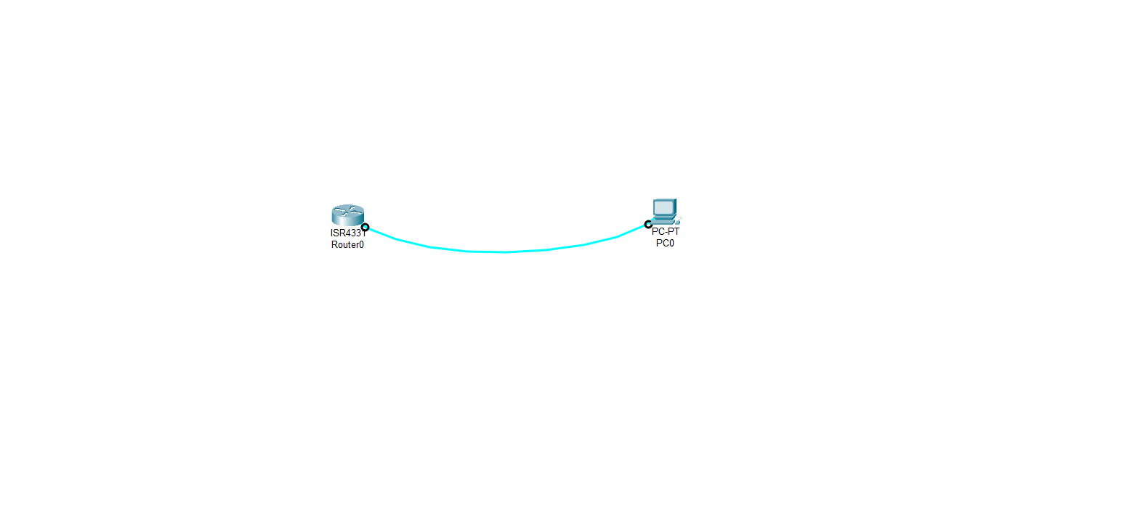

**Step – 3 :-**  Now Click on the PC and you will get all the information about PC.

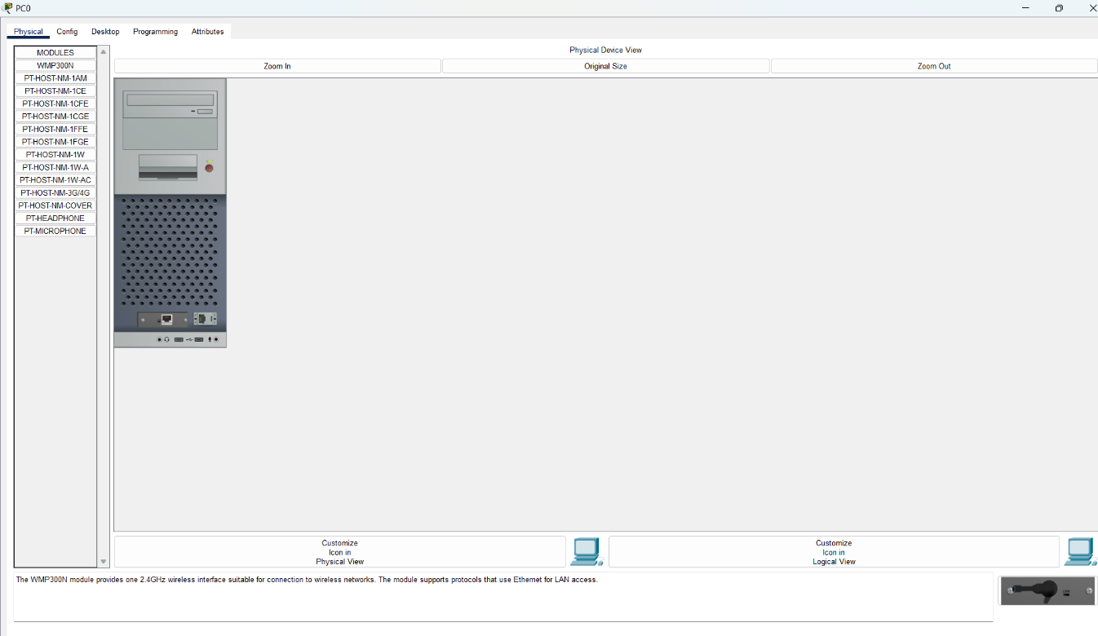

**Step – 4 :-**  Now Click on the Desktop and you will get this kind of interface.

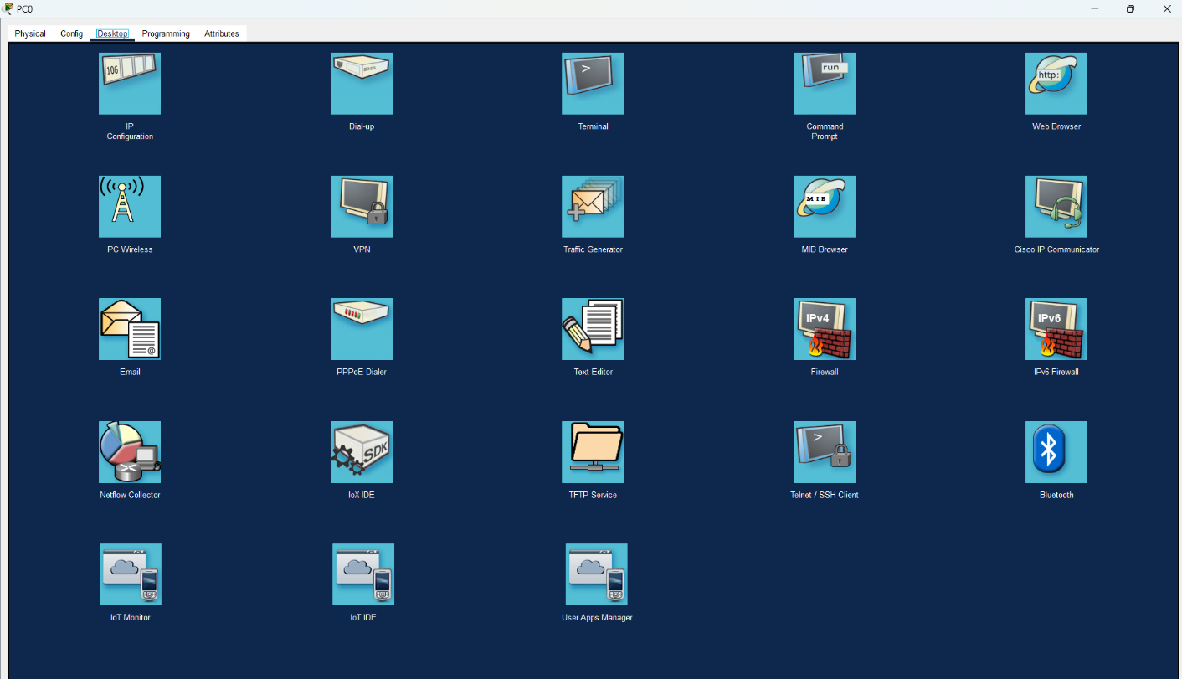

**Step – 5 :-**  Now Click on the terminal and you will get this kind of interface.

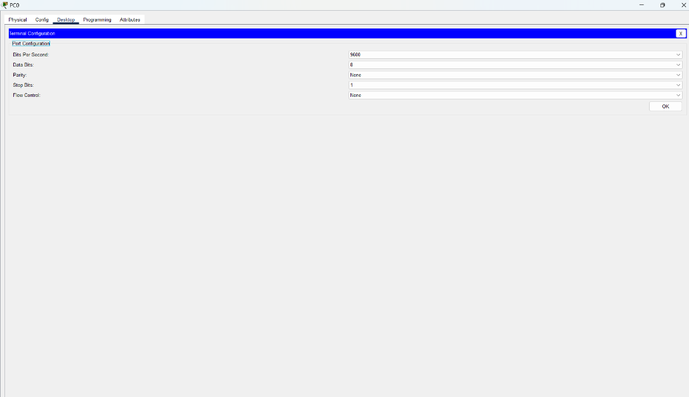

**Step – 6 :-**  Now Hit OK and you will get this kind of interface.

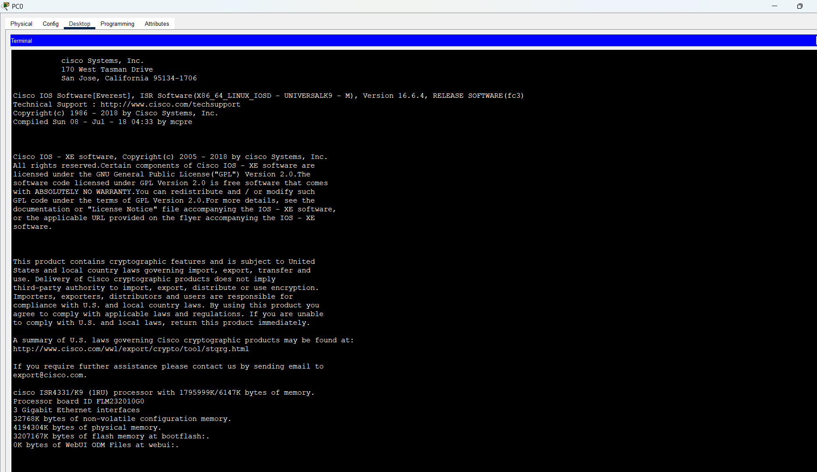

**Step – 7 :-**  Now Hit OK and you will get this kind of interface.



**Step – 8 :-**  Here we are getting CLI for configuring the router. Routers have 3 modes of operation:-

* **User EXEC Mode**:
  + It is shown by Router>
  + It has Basic access and limited commands.
  + It is used to view basic system information.
* **Privileged EXEC Mode**:
  + It is shown by Router#>
  + It has More advanced commands, including viewing configuration and system settings.
  + It is used to access to detailed commands, including system diagnostics and troubleshooting.
* **Global Configuration Mode**:
  + It is shown by Router(config)#>
  + It can change the router’s configuration.
  + It can Modify system settings like interfaces, routing protocols, and more. Sub-modes are also available to configure specific features.
* 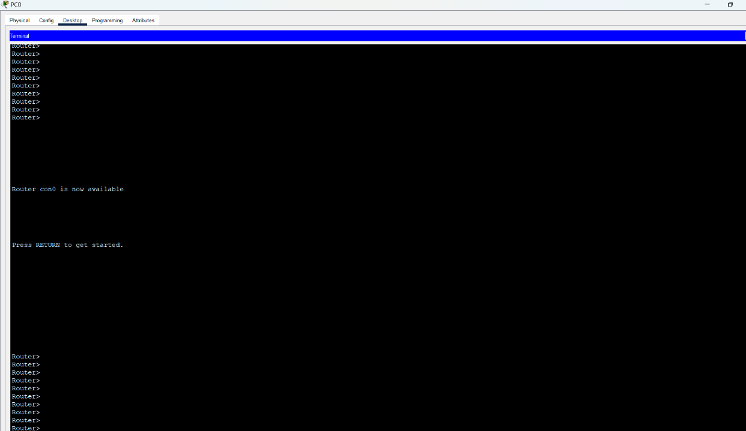By default router is in the user mode.

**Step – 9 :-**  Enter the command “enable” to enter into privilege mode.

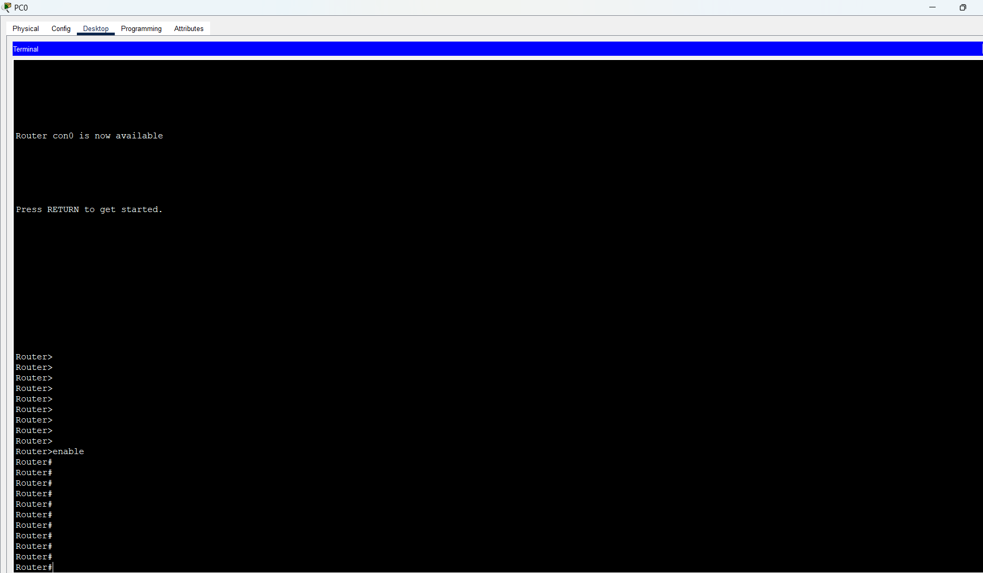

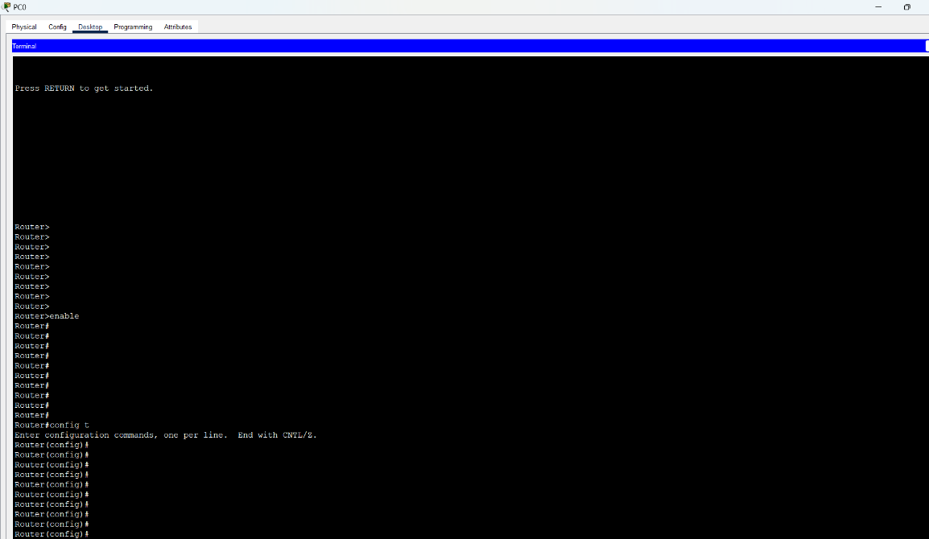**Step – 10 :-**  Enter the command “config t” to enter into configuration mode.

**Step – 11 :-**  Enter the command “hostname host_name” to change the name of host.

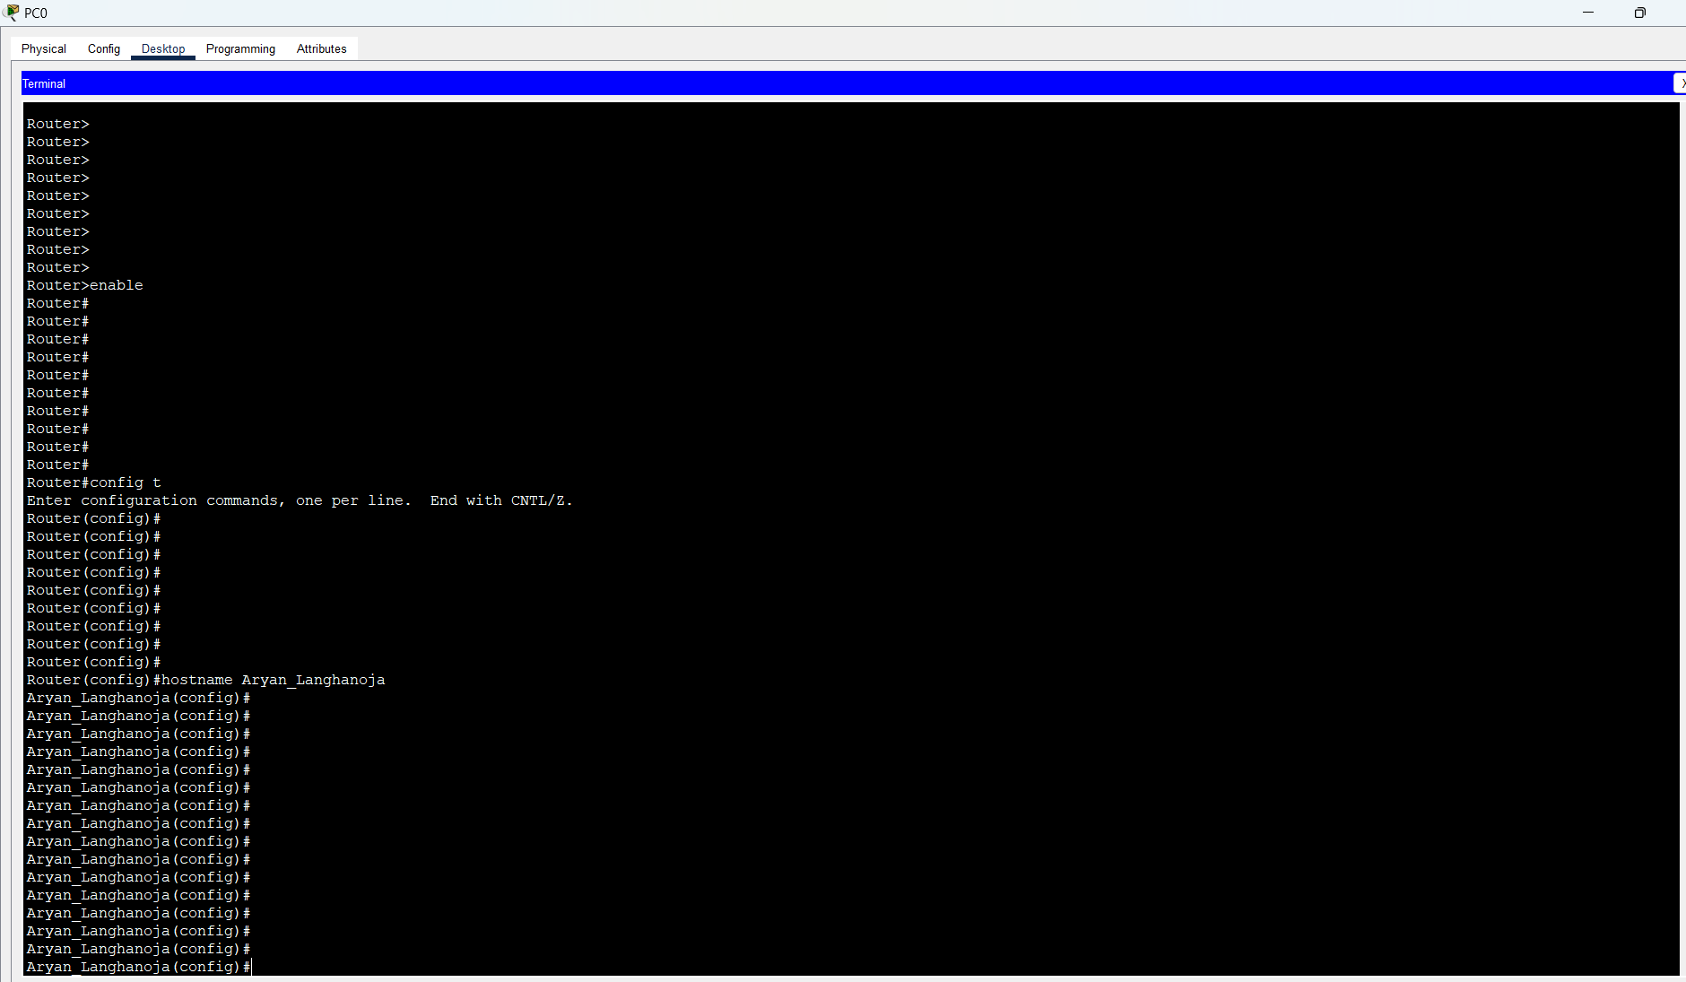

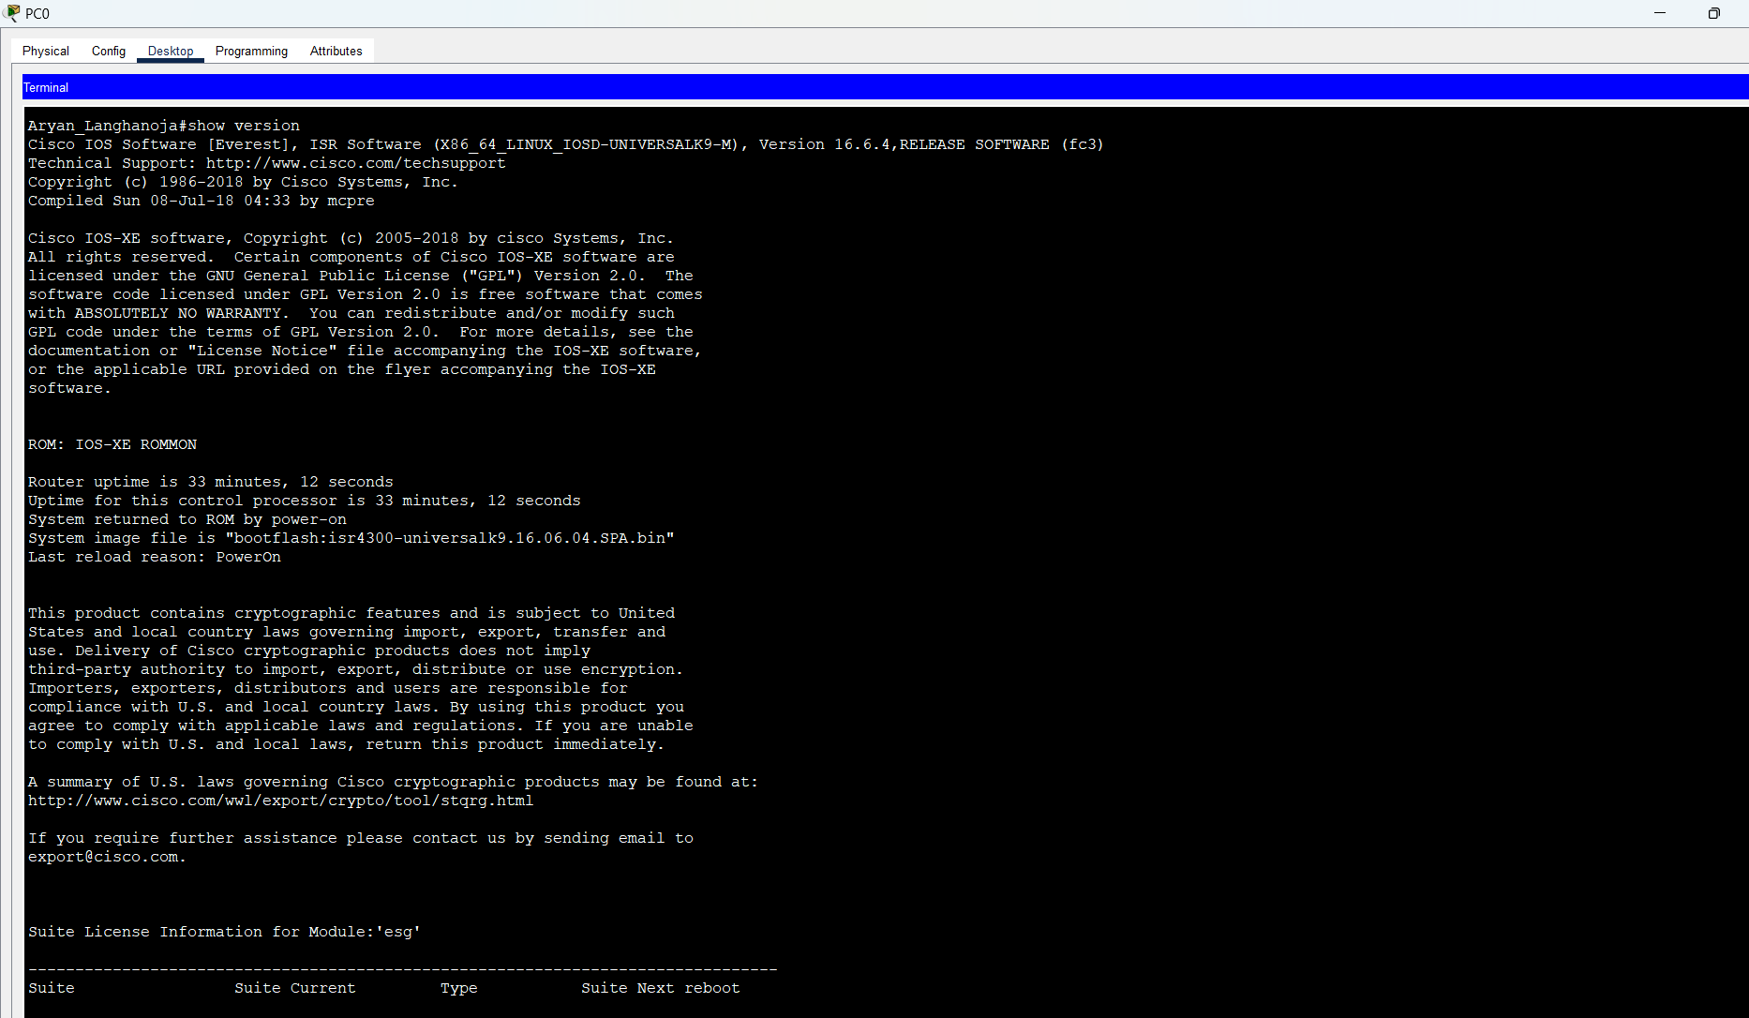**Step – 12 :-**  Enter the command “show version” to get the version information.

**Step – 13 :-**  Enter the command “show running-config” to get the running configuration of the router.

**Step – 14 :-**  Enter the command “s hip int brief” to get the information about various port.

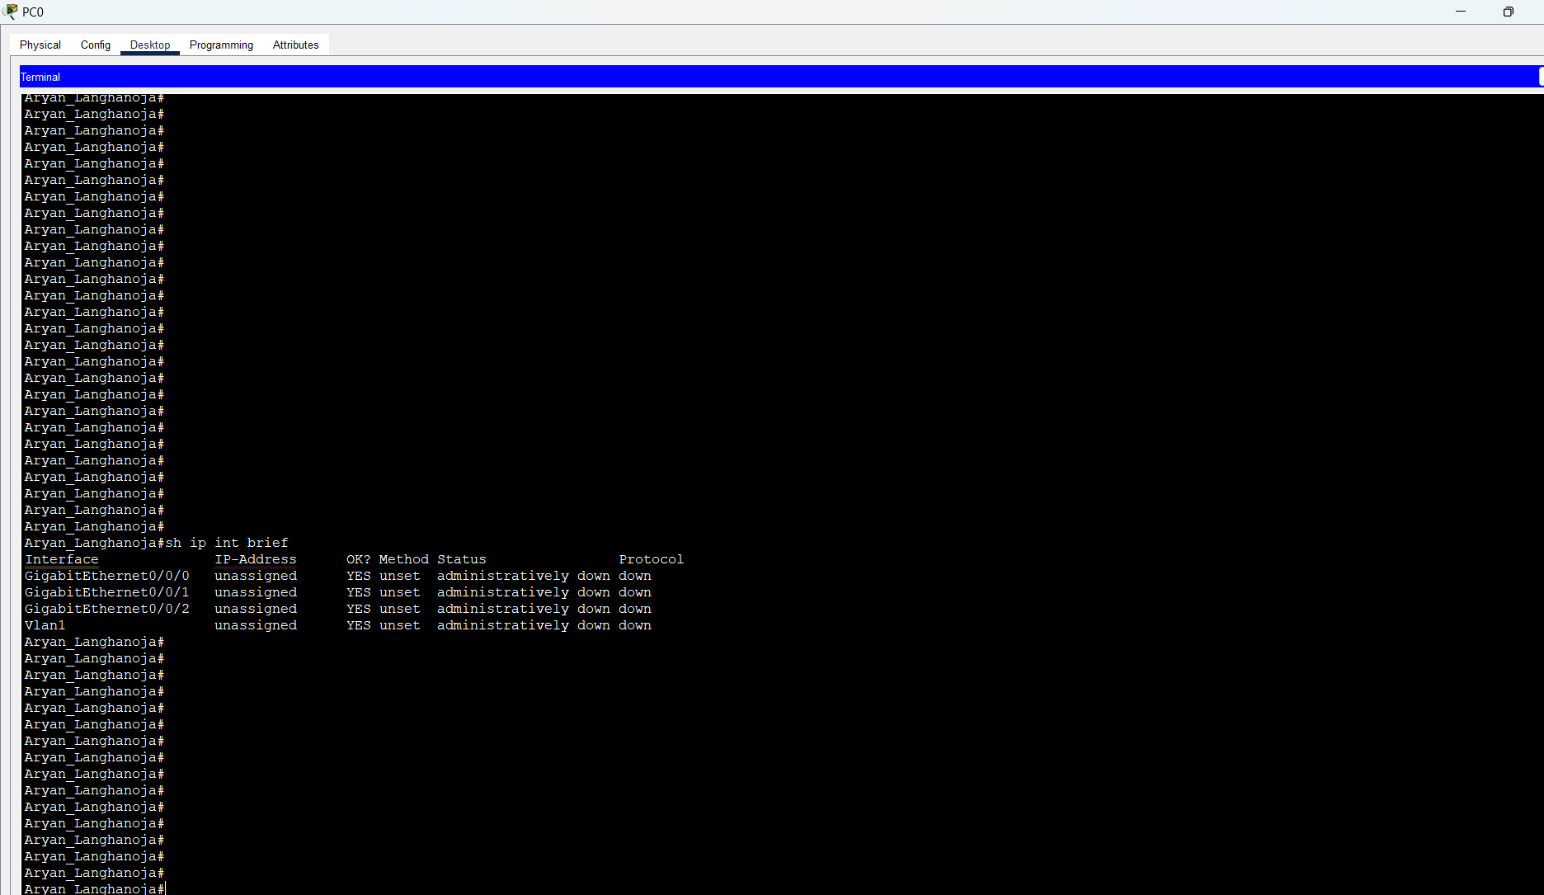

**Conclusion :-**

By Performing this experiment I came to know about the various modes of Cisco routers and various commands to configure it. we also learned about how to get the current configuration of the routers, various ports of the routes.